Print This Many Copies

1 copy per Non-Novice Policy Team of Judging Policy Debate

4 copies per Novice Policy Team of Judging Novice Policy Debate

1 copy per LD Debater of Judging LD Debate

1 copy per Parli Debate Team of Judging Parli Debate

1 copy per Public Forum Debate Team of Judging Public Forum Debate

NOTE: ADJUST SHEETS FOR TOPICS, YOUR TOURNAMENT’S RULES

FOR ELIMS

Do not start the round until you confirm all 3 judges.

Be sure to confirm the names of the teams and their side in the debate.

Disclose your decision to the debaters and immediately return ballots to Hunter foyer.

Do not start the round until you confirm all 3 judges.

Be sure to confirm the names of the teams and their side in the debate.

Disclose your decision to the debaters and immediately return ballots to Hunter foyer.

Do not start the round until you confirm all 3 judges.

Be sure to confirm the names of the teams and their side in the debate.

Disclose your decision to the debaters and immediately return ballots to Hunter foyer.

Do not start the round until you confirm all 3 judges.

Be sure to confirm the names of the teams and their side in the debate.

Disclose your decision to the debaters and immediately return ballots to Hunter foyer.
JUDGING POLICY DEBATE Example Policy Ballot
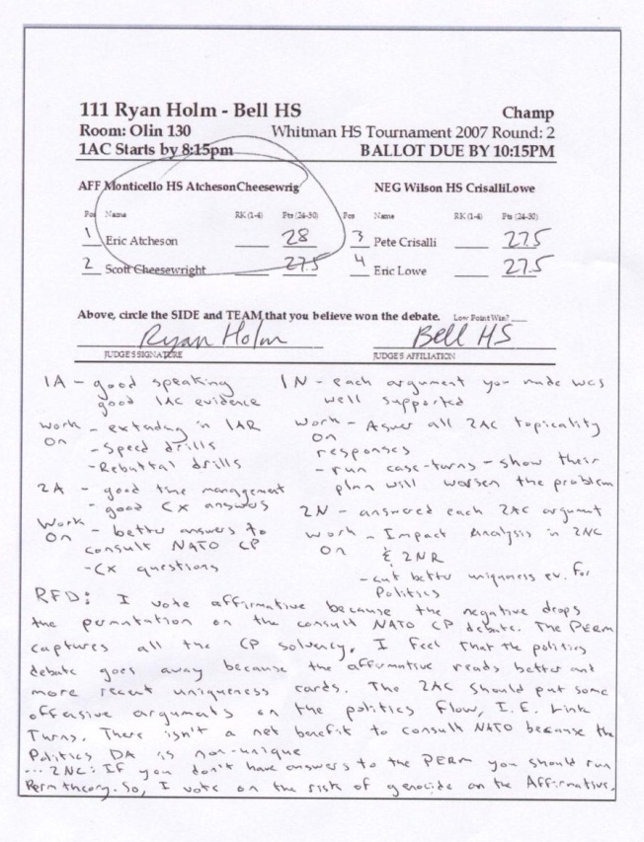
1. GO TO THE ROOM LISTED ON YOUR BALLOT
2. GREET THE DEBATERS
At the beginning of the round, check with the debaters to make sure you have the right teams. TELL THE DEBATERS WHAT KIND OF A DEBATE YOU WISH TO SEE. IF YOU HAVEN'T SEEN A DEBATE BEFORE--TELL THE STUDENTS TO SPEAK SLOWLY.
3. BEGIN THE DEBATE BY THE 1AC START TIME
If the 1AC does not start within 10 minutes of the 1ac start time, you must forfeit the team with missing debaters unless they have a really good excuse.
4. DURING THE ROUND, TIME THE DEBATERS; PLUS TAKE NOTES!
Give the debaters time signals during the speeches indicating how much time remains in the speech, usually out loud. You can also let the debaters time themselves (usually in sr. and champ division only). Stop debaters when their time is expired. They can finish a sentence of a piece of evidence but they cannot present more arguments. Speaking times are 8-3-5 with 6 minutes preparation for each side. Take careful notes of arguments they present.
5. DURING PREP TIME, WRITE COMMENTS
- Give ideas for drills: “You need four step refutation drills”
- Give ideas for theory that they need to work on: “You should work on your understanding of topicality.”
- Give ideas for arguments/strategies: “You should try to argue that the plan is bad, not just that it won’t solve.”
- Give ideas for research. “You should research arguments showing your plan helps the economy against spending disadvantages.”
6. AT THE END OF THE DEBATE, RATE THE DEBATERS
Rate the debaters using the point system on the ballot (24.1 to 29.9 with most scores being 26.1 to 28.1; you SHOULD use .1 increments, eg 27.8)
7. FILL OUT THE REASON FOR DECISION ON YOUR BALLOT
--MAKE A DECISION; WRITE THE WINNING SIDE ON THE BALLOT (AFFIRMATIVE OR NEGATIVE).

PLEASE DON’T . . .
These are the most common complaints we receive about judging in debate. Avoid them!
- Do not make up rules that are not on your ballot.
- PLEASE DO NOT MAKE UP ARGUMENTS AGAINST ONE OF THE DEBATERS. Let the debaters debate—you judge what THEY argue.
- Unless an argument is EXCEPTIONALLY bad, you should consider that argument “true” for the debate unless the other debater responded to it.
- Do not shave speaker time (shorten the debater’s speaking time).
- Do not show favoritism toward particular contestants.
- Do not go to other people to make a decision. You are to make a decision/rank/rate speakers ON YOUR OWN.
- Do not change or makeup topics. The students use the NFL Policy topic.
- Do not make mean comments on the ballot or during the round. Focus on what the speaker did well and what the speaker could improve on.
- Do not comment on a student’s physical looks (either positive or negative—these can easily be conceived of as harassment).
- Do not tell observers that they can’t watch or flow. ANYONE CAN WATCH ROUNDS so long as they are not disruptive (e.g. loud or rude).
PLEASE Turn off cell phones, instant messaging, videos, etc. during speeches.
--Oral decisions are fine and are encouraged.
--YOU MUST TURN IN YOUR BALLOT BY THE DEADLINE. No exceptions, no excuses, fines are assessed.
HOW SHOULD I MAKE A DECISION?
List out the good and the bad parts of the affirmative advocacy. Does the good outweigh the bad? Does the affirmative advocacy support the resolution? Any other issues that would lead you to reject the affirmative or the negative team’s advocacy? Explain in, at least, a paragraph, which issues convinced you to vote the way that you did. If you need more room, ask the ballot table for an additional ballot.
USE THE NOTES YOU TAKE DURING THE DEBATE TO HELP. Here is an example decision (not this year’s topic):
- "I felt the affirmative showed that their peacekeeping policy would stop genocide in Sudan. The negative tried to say that genocide would continue. But the affirmative evidence showed that officers using the plan have stopped such atrocities in the past. So, I voted affirmative."
WHEN YOU WRITE YOUR DECISION
- Explain your decision. USE COMPLETE, CLEAR SENTENCES. "I voted affirmative because they showed peacekeeping would . . ."
- Explain why you did not vote for the arguments of the losing team. Try to point to arguments that the winning team made that convinced you against these arguments. "The negative arguments about peacekeepers failing ignored the three affirmative studies showing improvements."
- Explain what the losing team needed to do to win the debate. "The negative needed better evidence that showed why these programs would not work."
POLICY DEBATE TIMES
- 8 minutes first affirmative
3 minutes cross-examination
- 8 minutes first negative
3 minutes cross-examination
- 8 minutes second affirmative
3 minutes cross-examination
- 8 minutes second negative
3 minutes cross-examination
- 5 minutes first negative rebuttal
- 5 minutes first affirmative rebuttal
- 5 minutes second negative rebuttal
- 5 minutes second affirmative rebuttal
6 minutes of preparation time
CAN I INTERJECT MY OPINION INTO MY DECISION?
Avoid it. You should not make a decision based solely on your beliefs. For example, it would be wrong to vote against a case simply because you didn't like it. DO NOT MAKE ARGUMENTS AGAINST A TEAM. Make your decisions based on the arguments that the teams present in the debate. Blame the opponents that couldn't even make a response to the weak argument.
8. TURN IN YOUR BALLOT BY THE TIME DEADLINE
The ballot table is in Hunter Foyer. Deadlines for turning in your ballots are listed on the ballots.
YOU NEED TO BRING YOUR BALLOT BACK so you pick up your next ballot on time—INCLUDING IE BALLOTS.

9. YES—YOU CAN AND SHOULD REVEAL YOUR DECISION TO THE DEBATERS.
THE POLICY TOPIC IS: Resolved: The United States federal government should substantially increase its transportation infrastructure investment in the United States. Note: You are scheduled to judge every round unless you paid for rounds off.
JUDGING NOVICE POLICY DEBATE Example Policy Ballot
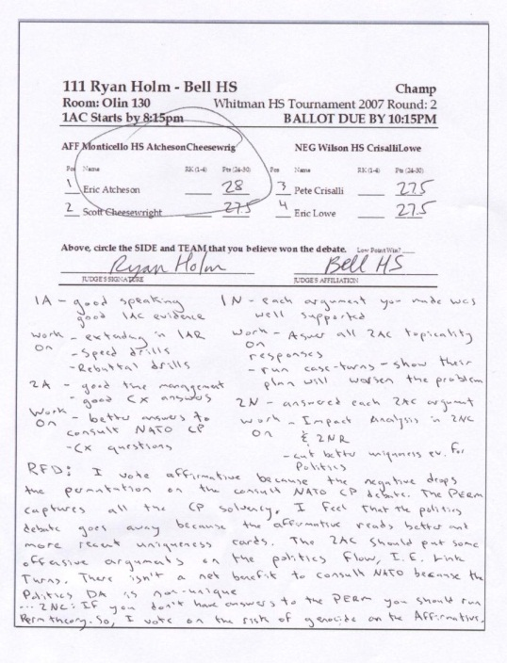
1. GO TO THE ROOM LISTED ON YOUR BALLOT
2. GREET THE DEBATERS
At the beginning of the round, check with the debaters to make sure you have the right teams. TELL THE DEBATERS WHAT KIND OF A DEBATE YOU WISH TO SEE. IF YOU HAVEN'T SEEN A DEBATE BEFORE--TELL THE STUDENTS TO SPEAK SLOWLY.
3. BEGIN THE DEBATE BY THE 1AC START TIME
If the 1AC does not start within 10 minutes of the 1ac start time, you must forfeit the team with missing debaters unless they have a really good excuse.
4. DURING THE ROUND, TIME THE DEBATERS; PLUS TAKE NOTES!
Give the debaters time signals during the speeches indicating how much time remains in the speech, usually out loud. You can also let the debaters time themselves (usually in sr. and champ division only). Stop debaters when their time is expired. They can finish a sentence of a piece of evidence but they cannot present more arguments. Speaking times are 8-3-5 with 6 minutes preparation for each side. Take careful notes of arguments they present.
5. DURING PREP TIME, WRITE COMMENTS
- Give ideas for drills: “You need four step refutation drills”
- Give ideas for theory that they need to work on: “You should work on your understanding of topicality.”
- Give ideas for arguments/strategies: “You should try to argue that the plan is bad, not just that it won’t solve.”
- Give ideas for research. “You should research arguments showing your plan helps the economy against spending disadvantages.”
6. AT THE END OF THE DEBATE, RATE THE DEBATERS
Rate the debaters using the point system on the ballot (24.1 to 29.9 with most scores being 26.1 to 28.1; you SHOULD use .1 increments, eg 27.8)

PLEASE DON’T . . .
These are the most common complaints we receive about judging in debate. Avoid them!
- Do not make up rules that are not on your ballot.
- PLEASE DO NOT MAKE UP ARGUMENTS AGAINST ONE OF THE DEBATERS. Let the debaters debate—you judge what THEY argue.
- Unless an argument is EXCEPTIONALLY bad, you should consider that argument “true” for the debate unless the other debater responded to it.
- Do not shave speaker time (shorten the debater’s speaking time).
- Do not show favoritism toward particular contestants.
- Do not go to other people to make a decision. You are to make a decision/rank/rate speakers ON YOUR OWN.
- Do not change or makeup topics. The students use the NFL Policy topic.
- Do not make mean comments on the ballot or during the round. Focus on what the speaker did well and what the speaker could improve on.
- Do not comment on a student’s physical looks (either positive or negative—these can easily be conceived of as harassment).
- Do not tell observers that they can’t watch or flow. ANYONE CAN WATCH ROUNDS so long as they are not disruptive (e.g. loud or rude).
PLEASE Turn off cell phones, instant messaging, videos, etc. during speeches.
7. FILL OUT THE REASON FOR DECISION ON YOUR BALLOT
--MAKE A DECISION; WRITE THE WINNING SIDE ON THE BALLOT (AFFIRMATIVE OR NEGATIVE).
--Oral decisions are fine and are encouraged.
--YOU MUST TURN IN YOUR BALLOT BY THE DEADLINE. No exceptions, no excuses, fines are assessed.
HOW SHOULD I MAKE A DECISION?
List out the good and the bad parts of the affirmative advocacy. Does the good outweigh the bad? Does the affirmative advocacy support the resolution? Any other issues that would lead you to reject the affirmative or the negative team’s advocacy? Explain in, at least, a paragraph, which issues convinced you to vote the way that you did. If you need more room, ask the ballot table for an additional ballot.
USE THE NOTES YOU TAKE DURING THE DEBATE TO HELP. Here is an example decision (not this year’s topic):
- "I felt the affirmative showed that their peacekeeping policy would stop genocide in Sudan. The negative tried to say that genocide would continue. But the affirmative evidence showed that officers using the plan have stopped such atrocities in the past. So, I voted affirmative."
WHEN YOU WRITE YOUR DECISION
- Explain your decision. USE COMPLETE, CLEAR SENTENCES. "I voted affirmative because they showed peacekeeping would . . ."
- Explain why you did not vote for the arguments of the losing team. Try to point to arguments that the winning team made that convinced you against these arguments. "The negative arguments about peacekeepers failing ignored the three affirmative studies showing improvements."
POLICY DEBATE TIMES
- 8 minutes first affirmative
3 minutes cross-examination
- 8 minutes first negative
3 minutes cross-examination
- 8 minutes second affirmative
3 minutes cross-examination
- 8 minutes second negative
3 minutes cross-examination
- 5 minutes first negative rebuttal
- 5 minutes first affirmative rebuttal
- 5 minutes second negative rebuttal
- 5 minutes second affirmative rebuttal
6 minutes of preparation time
- Explain what the losing team needed to do to win the debate. "The negative needed better evidence that showed why these programs would not work."
CAN I INTERJECT MY OPINION INTO MY DECISION?
Avoid it. You should not make a decision based solely on your beliefs. For example, it would be wrong to vote against a case simply because you didn't like it. DO NOT MAKE ARGUMENTS AGAINST A TEAM. Make your decisions based on the arguments that the teams present in the debate. Blame the opponents that couldn't even make a response to the weak argument.
8. TURN IN YOUR BALLOT BY THE TIME DEADLINE
The ballot table is in Hunter Foyer. Deadlines for turning in your ballots are listed on the ballots.
YOU NEED TO BRING YOUR BALLOT BACK so you pick up your next ballot on time—INCLUDING IE BALLOTS.

9. YES—YOU CAN AND SHOULD REVEAL YOUR DECISION TO THE DEBATERS.
THE POLICY TOPIC IS: Resolved: The United States federal government should substantially increase its transportation infrastructure investment in the United States. Note: You are scheduled to judge every round unless you paid for rounds off. Novices are restricted in the arguments they may present in policy debate:
Allowed affirmative cases  • Hi-speed passenger rail: intra-region rail to connect large metropolitan areas; excludes light rail  • Urban public transportation: buses only for urban transportation  • Next generation air transport system: accelerate the implementation, now scheduled for 2025  • Port Security: increase the investment in port security infrastructure  • Electric car stations: increase electric car charging stations  • National Infrastructure Bank: create a National Infrastructure Bank, as articulated in the American Jobs Act. No funding specification for particular projects | Negatives can run the States counterplan.  Kritiks and specification theory arguments are not allowed.  There is no guarantee that running a novice case means the plan is topical.
JUDGING LD DEBATE Example LD Ballot

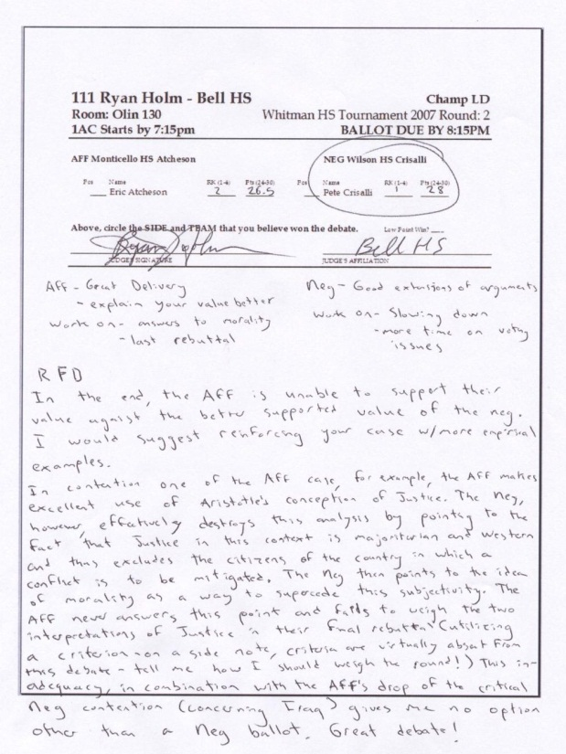
1. GO TO THE ROOM LISTED ON YOUR BALLOT
You will watch two debates in that room during this round; except
Round 2, quarterfinals, semi-finals, and finals, you watch just one.
2. GREET THE DEBATERS
At the beginning of the round, check with the debaters to make sure you have the right teams. TELL THE DEBATERS WHAT KIND OF A DEBATE YOU WISH TO SEE. IF YOU HAVEN'T SEEN A DEBATE BEFORE--TELL THE STUDENTS TO SPEAK SLOWLY.
3. BEGIN THE DEBATES BY 1AC START TIME
MISSING DEBATERS? If a Flight A debater is missing but both Flight B debaters are there, have the Flight B debate. You must forfeit any LD debater who is not there to begin their flight within 10 minutes of start time unless they have a really good excuse or you can have flight A go after flight B.
4. TIME AND TAKE NOTES DURING DEBATES!
Give the debaters time signals with your fingers indicating how much time is remaining in their speech (e.g. 4 fingers for 4 minutes remaining). You can also let the debaters time themselves (usually in sr. and champ division only). Stop debaters when their time is expired. They can finish a sentence of a piece of evidence but they cannot present more arguments. Speaking times noted below, right side. Take careful notes of the arguments they present.
5. DURING PREP TIME, WRITE COMMENTS
- Give ideas for drills: “You need four step refutation drills”
- Give ideas for theory that they need to work on: “You should work on your understanding of criteria.”
- Give ideas for arguments/strategies: “You should try to argue that the value is bad, not just that it is insufficient.”
- Give ideas for research. “You should research arguments showing your value achieves liberty and freedom.”
6. AT THE END OF EACH DEBATE, RATE THE DEBATERS
Rate the debaters using the point system on the ballot (24.1 to 29.9 with most scores being 26.1 to 28.1; you SHOULD use .1 increments, eg 27.8)

PLEASE DON’T . . .
These are the most common complaints we receive about judging in debate. Avoid them!
- Do not make up rules that are not on your ballot.
- PLEASE DO NOT MAKE UP ARGUMENTS AGAINST ONE OF THE DEBATERS. Let the debaters debate—you judge what THEY argue.
- Unless an argument is EXCEPTIONALLY bad, you should consider that argument “true” for the debate unless the other debater responded to it.
- Do not shave speaker time (shorten the debater’s speaking time).
- Do not show favoritism toward particular contestants.
- Do not go to other people to make a decision. You are to make a decision/rank/rate speakers ON YOUR OWN.
- Do not change or makeup topics. The students use the NFL LD topic.
- Do not make mean comments on the ballot or during the round. Focus on what the speaker did well and what the speaker could improve on.
- Do not comment on a student’s physical looks (either positive or negative—these can easily be conceived of as harassment).
- Do not tell observers that they can’t watch or flow. ANYONE CAN WATCH ROUNDS so long as they are not disruptive (e.g. loud or rude).
PLEASE Turn off cell phones, instant messaging, videos, etc. during speeches.
7. FILL OUT THE REASON FOR DECISION ON YOUR BALLOT
--MAKE A DECISION; WRITE THE WINNING SIDE ON THE BALLOT (AFFIRMATIVE OR NEGATIVE).
--YOU CAN GIVE AN ORAL CRITIQUE BUT YOUR BALLOTS MUST BE TURNED IN BEFORE THE DEADLINE OR YOUR SCHOOL IS FINED.
HOW SHOULD I MAKE A DECISION?
List out the arguments for and against the topic. Do the arguments for outweigh the arguments against? Be sure to consider the value and criteria presented in deciding which side's arguments are more important. Does the affirmative case support the topic? USE YOUR NOTES OF THEIR ARGUMENTS. Explain in, at least, a paragraph, which issues convinced you to vote the way that you did. If you need more room, ask the ballot table for an additional ballot.
Here is an example decision you might make (not this year’s topic):
- "The negative established that promoting democracy winds up just imposing economic hardship on countries. The affirmative tried to focus on freedom as an imperative. The negative, demonstrated, however, that promotion of democracy actually winds up undermining freedom because corporations dominate and undermine individual voices."
WHEN YOU WRITE YOUR DECISION
- Explain your decision. USE COMPLETE, CLEAR SENTENCES. "I voted negative because they showed that democratic ideals . . ."
- Explain why you did not vote for the arguments of the losing team. Try to point to arguments that the winning team made that convinced you against these arguments. "The affirmative arguments about democracy helping freedom ignored the three negative arguments showing . . . "
LD DEBATE TIMES
- 6 minutes for affirmative speech
3 min cross-examination
- 7 minutes for negative speech
3 min cross-examination
- 4 minutes for first aff. rebuttal
- 6 minutes for negative rebuttal
- 3 minutes for the last aff. rebuttal
4 min preparation time
- Explain what the losing debater needed to do to win the debate. "The affirmative needed better analysis showing that democracy has empirically helped people."
CAN I INTERJECT MY OPINION INTO MY DECISION?
Avoid it. You should not make a decision based solely on your beliefs. For example, it would be wrong to vote against a case simply because you didn't like it. DO NOT MAKE ARGUMENTS AGAINST A DEBATER. Make your decisions based on arguments that the debaters present in the debate. Blame the opponent that did not make a response to the weak argument.
8. TURN IN YOUR BALLOTS BY THE TIME DEADLINE
The ballot table is in Hunter Foyer. Deadlines for turning in your ballots are listed on the ballots.
YOU NEED TO BRING YOUR BALLOT BACK so you pick up your next ballot on time—INCLUDING IE BALLOTS.

9. YES—YOU CAN AND SHOULD REVEAL YOUR DECISION TO THE DEBATERS.
THE LD TOPIC IS: Resolved: The United States ought to guarantee universal health care for its citizens. Note: You are scheduled to judge every round unless you paid for rounds off.
JUDGING PARLI DEBATE Example Parli Ballot

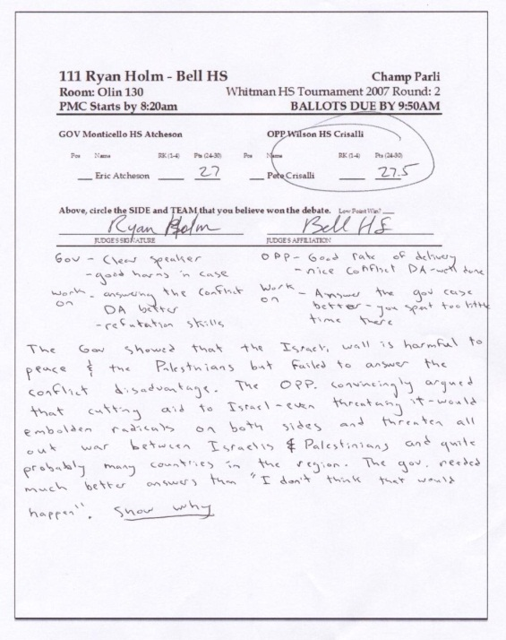
1. GO TO THE ROOM LISTED ON YOUR BALLOT
You will watch two debates in that room during this round.
2. GREET THE DEBATERS
At the beginning of the round, check with the debaters to make sure you have the right teams. TELL THE DEBATERS WHAT KIND OF A DEBATE YOU WISH TO SEE. IF YOU HAVEN'T SEEN A DEBATE BEFORE--TELL THE STUDENTS TO SPEAK SLOWLY.
3. BEGIN BY THE 1ST SPEAKER START TIME
If the First Speaker does not start within 10 minutes of the start time, you must forfeit the team with missing debaters unless they have a really good excuse.
4. DURING ROUND, TIME THE DEBATERS & TAKE NOTES!
Give the debaters time signals with your fingers indicating how much time is remaining in their speech (e.g. 3 fingers for 3 minutes remaining). You can also let the debaters time themselves (usually in Sr. division only). Stop debaters when their time is expired. They can finish a sentence but they cannot present more arguments. Speaking times noted below, right side. Take careful notes of the arguments they present.
IN PARLI DEBATE: Students MAY have an outlined case/arguments on their flowsheet or laptop flow. Students may refer to sources as you would in an extemporaneous speech during your speeches. STUDENTS MAY NOT directly quote (word for word) articles and THEY MAY NOT read a word for word written out speech.
You may look at their notes/laptop at any time you wish during the debate.
5. WRITE COMMENTS
- Give ideas for drills: “You need four step refutation drills”
- Give ideas for theory that they need to work on: “You should work on your understanding of the stock issues.”
- Give ideas for arguments/strategies: “You should try to argue that the value is bad, not just that it is insufficient.”
6. RATE THE DEBATERS

PLEASE DON’T . . .
These are the most common complaints we receive about judging in debate. Avoid them!
- Do not make up rules that are not on your ballot.
- PLEASE DO NOT MAKE UP ARGUMENTS AGAINST ONE OF THE DEBATERS. Let the debaters debate—you judge what THEY argue.
- Unless an argument is EXCEPTIONALLY bad, you should consider that argument “true” for the debate unless the other debater responded to it.
- Do not shave speaker time (shorten the debater’s speaking time).
- Do not show favoritism toward particular contestants.
- Do not go to other people to make a decision. You are to make a decision/rank/rate speakers ON YOUR OWN.
- Do not change or makeup topics. Students use topics in our invitation.
- Do not make mean comments on the ballot or during the round. Focus on what the speaker did well and what the speaker could improve on.
- Do not comment on a student’s physical looks (either positive or negative—these can easily be conceived of as harassment).
- Do not tell observers that they can’t watch or flow. ANYONE CAN WATCH ROUNDS so long as they are not disruptive (e.g. loud or rude).
PLEASE Turn off cell phones, instant messaging, videos, etc. during speeches.

Rate the debaters using the point system on the ballot (24.1 to 29.9 with most scores being 26.1 to 28.1; you SHOULD use .1 increments, eg 27.8)
7. FILL OUT THE REASON FOR DECISION
--MAKE A DECISION; WRITE THE WINNING SIDE ON THE BALLOT (GOVERNMENT OR OPPOSITION).
--YOU CAN GIVE AN ORAL CRITIQUE BUT YOUR BALLOTS MUST BE TURNED IN BEFORE THE DEADLINE OR YOUR SCHOOL IS FINED.
HOW SHOULD I MAKE A DECISION?
List out the good and the bad parts of the government advocacy. Does the good outweigh the bad? Does the government advocacy support the resolution? Any other issues that would lead you to reject the government or the opposition team’s advocacy? USE THE NOTES YOU TAKE DURING THE DEBATE TO HELP. Explain in, at least, a paragraph, which issues convinced you to vote the way that you did. If you need more room, ask the ballot table for an additional ballot.
Here is an example decision:
- "I felt the government showed that their health policy would stop genocide in Sudan. The opposition tried to say that genocide would continue. But the government showed that health programs stopped such atrocities in the past. So, I voted government."
WHEN YOU WRITE YOUR DECISION
- Explain your decision. USE COMPLETE, CLEAR SENTENCES. "I voted government because they showed a new health plan would . . ."
- Explain why you did not vote for the arguments of the losing team. Try to point to arguments that the winning team made that convinced you against these arguments. "The opposition arguments about the health program failing ignored the three government arguments showing improvements."
- Explain what the losing team needed to do to win the debate. "The opposition needed better evidence that showed why these programs would not work."
CAN I INTERJECT MY OPINION INTO MY DECISION?
PARLI DEBATE TIMES
- Topics were announced before the tournament started so students head to rounds when the round is posted.
- Prime Minister Constructive: 3min.
45 seconds preparation
- Leader of Opposition Constructive: 4 min.
45 seconds preparation
- Member of Government Constructive 4 min.
45 seconds preparation
- Member of Opposition Constructive 4 min.
- Leader of Opposition Rebuttal 2.5 min.
45 seconds preparation
- Prime Minister Rebuttal 3 min.
Avoid it. For example, it would be wrong to vote against a case simply because you didn't like it. DO NOT MAKE ARGUMENTS AGAINST A DEBATER. Make your decisions based on the arguments that the debaters present in the debate. Blame the opponent that couldn't even make a response to the weak argument.
8. TURN IN YOUR BALLOTS BY THE TIME DEADLINE
The ballot table is in Hunter Foyer. Deadlines for turning in your ballots are listed on the ballots.
YOU NEED TO BRING YOUR BALLOT BACK so you pick up your next ballot on time—INCLUDING IE BALLOTS.

9. YES—YOU CAN AND SHOULD REVEAL YOUR DECISION TO THE DEBATERS.

TOPIC FOR THE DEBATE? See the Warm Room Page or ask the debaters.

Note: You are scheduled to judge every round unless you paid for rounds off.
JUDGING PUBLIC FORUM DEBATE EG Public Forum Ballot
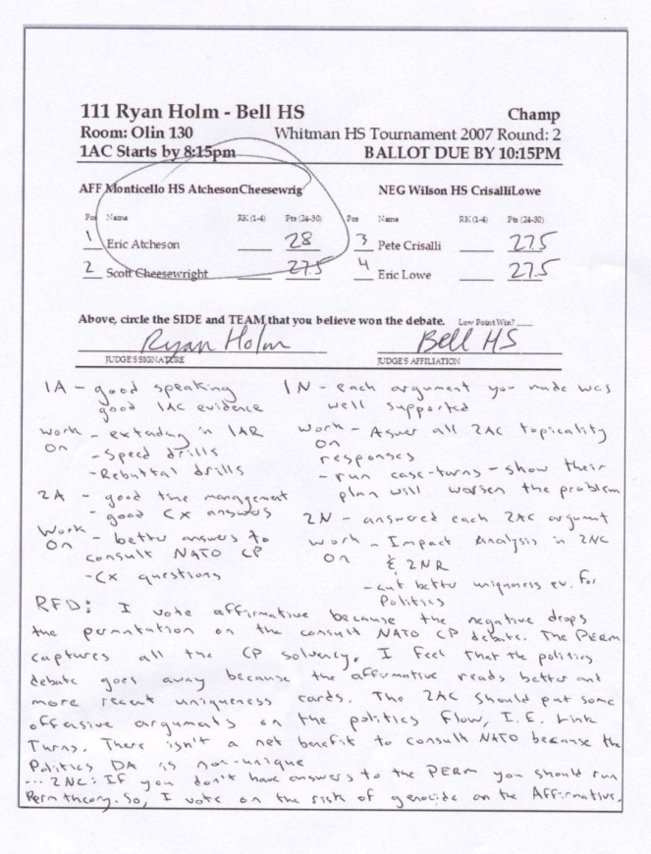
1. GO TO THE ROOM LISTED ON YOUR BALLOT
2. GREET THE DEBATERS
At the beginning of the round, check with the debaters to make sure you have the right teams. TELL THE DEBATERS WHAT KIND OF A DEBATE YOU WISH TO SEE. IF YOU HAVEN'T SEEN A DEBATE BEFORE--TELL THE STUDENTS TO SPEAK SLOWLY.
3. BEGIN THE DEBATE BY THE START TIME
If the First Speaker does not start within 10 minutes of the start time, you must forfeit the team with missing debaters unless they have a really good excuse.
4. NO COIN TOSS. Pro (aff) team speaks first.
5. DURING THE ROUND, TIME THE DEBATERS; PLUS TAKE NOTES!
Give the debaters time signals during the speeches indicating how much time remains in the speech, usually with hand signals. Stop debaters when their time is expired. They can finish a sentence or two but they cannot present more arguments. Take careful notes of arguments they present.
6. DURING PREP TIME, WRITE COMMENTS
- Give ideas for drills: “You need to work on responding to arguments.”
- Give ideas for arguments/strategies: “You should try to argue that the resolution’s policy is bad, not just that it won’t solve.”
- Give ideas for research. “Research arguments showing the resolution helps the economy.”
7. AT THE END OF THE DEBATE, RATE THE DEBATERS
Rate the debaters using the point system on the ballot (24.1 to 29.9 with most scores being 26.1 to 28.1; you SHOULD use .1 increments, eg 27.8)
8. FILL OUT THE REASON FOR DECISION ON YOUR BALLOT
--MAKE A DECISION; WRITE THE WINNING SIDE ON THE BALLOT (PRO OR CON).

PLEASE DON’T . . .
These are the most common complaints we receive about judging in debate. Avoid them!
- Do not make up rules that are not on your ballot.
- PLEASE DO NOT MAKE UP ARGUMENTS AGAINST ONE OF THE DEBATERS. Let the debaters debate—you judge what THEY argue.
- Unless an argument is EXCEPTIONALLY bad, you should consider that argument “true” for the debate unless the other debater responded to it.
- Do not shave speaker time (shorten the debater’s speaking time).
- Do not show favoritism toward particular contestants.
- Do not go to other people to make a decision. You are to make a decision/rank/rate speakers ON YOUR OWN.
- Do not change or makeup topics. Students use the NFL Public Forum topic.
- Do not make mean comments on the ballot or during the round. Focus on what the speaker did well and what the speaker could improve on.
- Do not comment on a student’s physical looks (either positive or negative—these can easily be conceived of as harassment).
- Do not tell observers that they can’t watch or flow. ANYONE CAN WATCH ROUNDS so long as they are not disruptive (e.g. loud or rude).
PLEASE Turn off cell phones, instant messaging, videos, etc. during speeches.
--Oral decisions are fine and are encouraged.
--YOU MUST TURN IN YOUR BALLOT BY THE DEADLINE. No exceptions, no excuses, fines are assessed.
HOW SHOULD I MAKE A DECISION?
List out the good and the bad parts of the pro-affirmative advocacy. Does the good outweigh the bad? Does the pro advocacy support the resolution? Any other issues that would lead you to reject the pro or the con team’s advocacy? Explain in, at least, a paragraph, which issues convinced you to vote the way that you did. If you need more room, ask the ballot table for an additional ballot.
USE THE NOTES YOU TAKE DURING THE DEBATE TO HELP. Here is an example decision (not this year’s topic):
- "I felt the pro showed that the peacekeeping policy would stop genocide in Sudan. The con tried to say that genocide would continue. But the pro evidence and reasoning showed that officers have stopped such atrocities in the past. So, I voted pro."
WHEN YOU WRITE YOUR DECISION
- Explain your decision. USE COMPLETE, CLEAR SENTENCES. "I voted pro because they showed peacekeeping would . . ."
- Explain why you did not vote for the arguments of the losing team. Try to point to arguments that the winning team made that convinced you against these arguments. "The con arguments about peacekeepers failing ignored the three pro studies showing improvements."
- Explain what the losing team needed to do to win the debate. "The con needed better evidence that showed why these programs would not work."
CAN I INTERJECT MY OPINION INTO MY DECISION?
Avoid it. You should not make a decision based solely on your beliefs. For example, it is wrong to vote against a case simply because you didn't like it. DO NOT MAKE ARGUMENTS AGAINST A TEAM. Make your decisions based on the arguments that the teams present in the debate. Blame the opponents that couldn't even make a response to the weak argument.
PUBLIC FORUM DEBATE TIMES
- NOTE: NO COIN FLIP. The Ballots and Postings state who is Pro and who is Con.
- PRO-AFF TEAM ALWAYS SPEAKS FIRST.
- Pro First Speaker: 4 Minutes
- Con First Speaker: 4 Minutes
Crossfire: 3 Minutes
- Pro Second Speaker: 4 Minutes
- Con Second Speaker: 4 Minutes
Crossfire: 3 Minutes
- Pro First Speaker Summary: 2 Minutes
- Con First Speaker Summary: 2 Minutes
Grand Crossfire: 3 Minutes
- Pro Second Speaker Final Focus: 2 Minutes
- Con Second Speaker Final Focus: 2 Minutes
Prep Time (per team): 2 Minutes.
9. TURN IN YOUR BALLOT BY THE TIME DEADLINE
The ballot table is in Hunter Foyer. Deadlines for turning in your ballots are listed on the ballots.
YOU NEED TO BRING YOUR BALLOT BACK so you pick up your next ballot on time—INCLUDING IE BALLOTS.

10. YES—YOU CAN AND SHOULD REVEAL YOUR DECISION TO THE DEBATERS.

THE TOPIC IS: Resolved: Current U.S. foreign policy in the Middle East undermines our national security.
THIS IS PUB FORUM: Pro Teams Support the Resolution, NOT a Plan.
Disads, Kritiks, Counterplans, Most Theory is NOT allowed. Focus on Pro and Con Cases. Drops of minor points should not be the focus of your decision. Focus on the big picture. It is about Persuasion–not technical details.
Note: You are scheduled to judge every round unless you paid for rounds off.

